New Address Link dispute is created

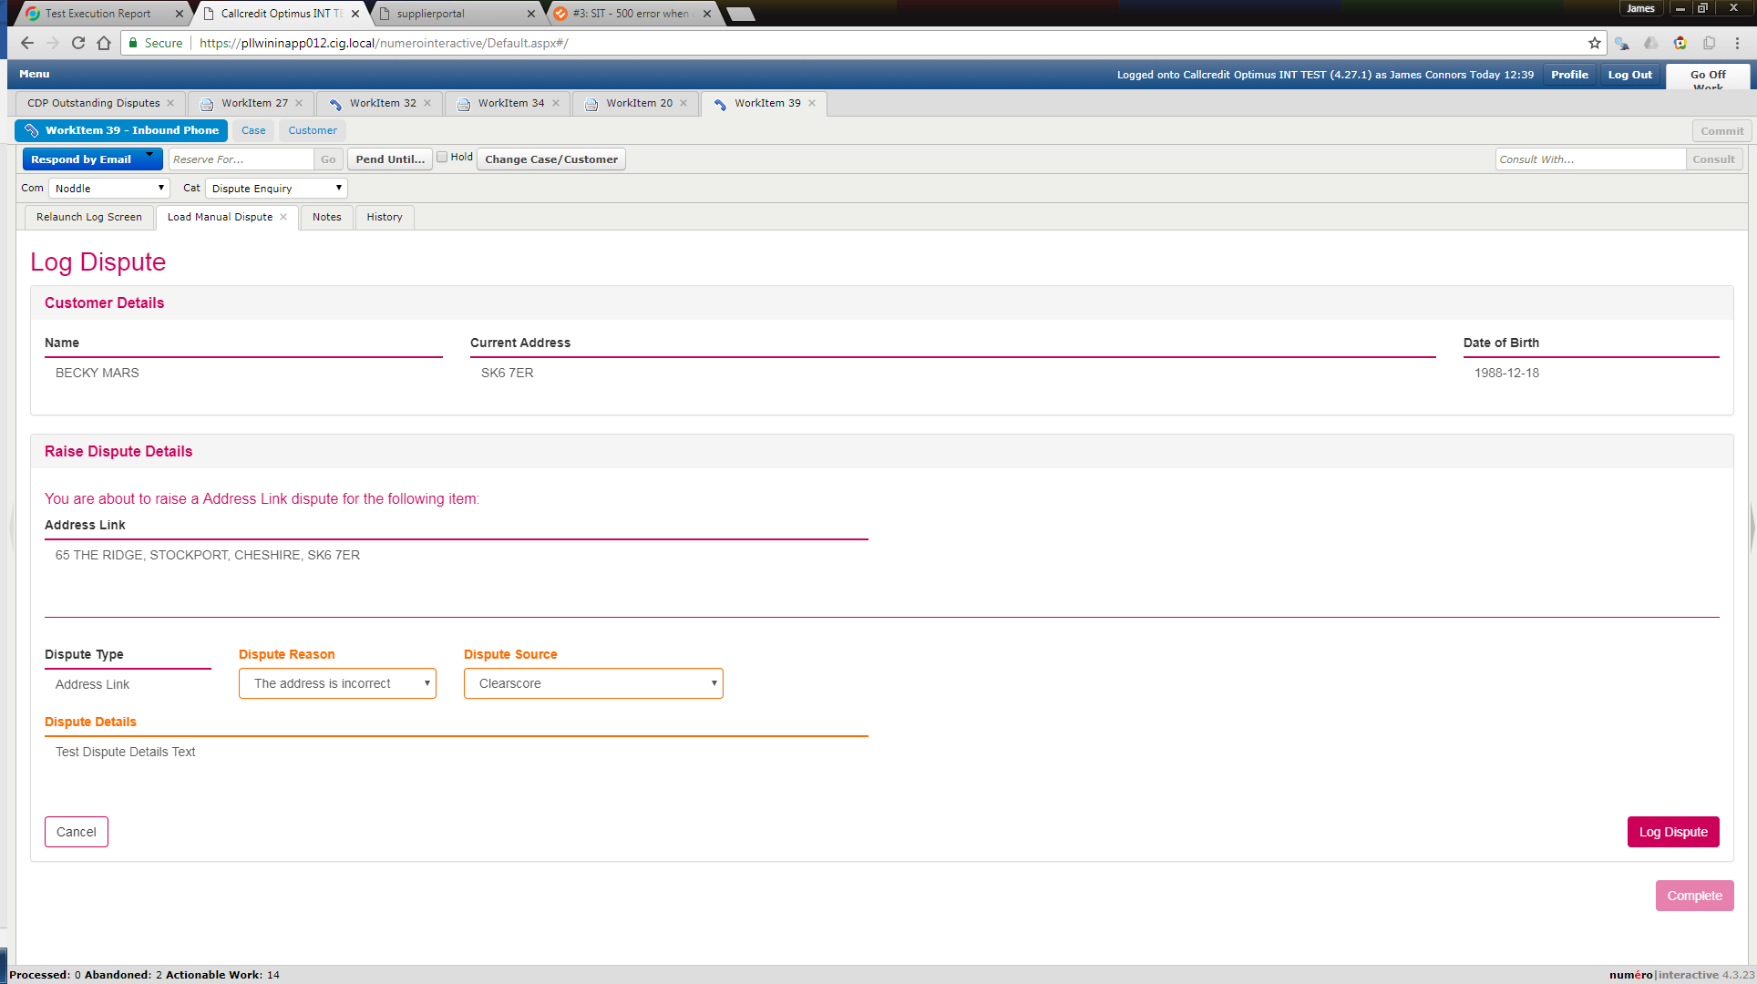

As expected the case is not created for 5 minutes and therefore is not yet in the below;

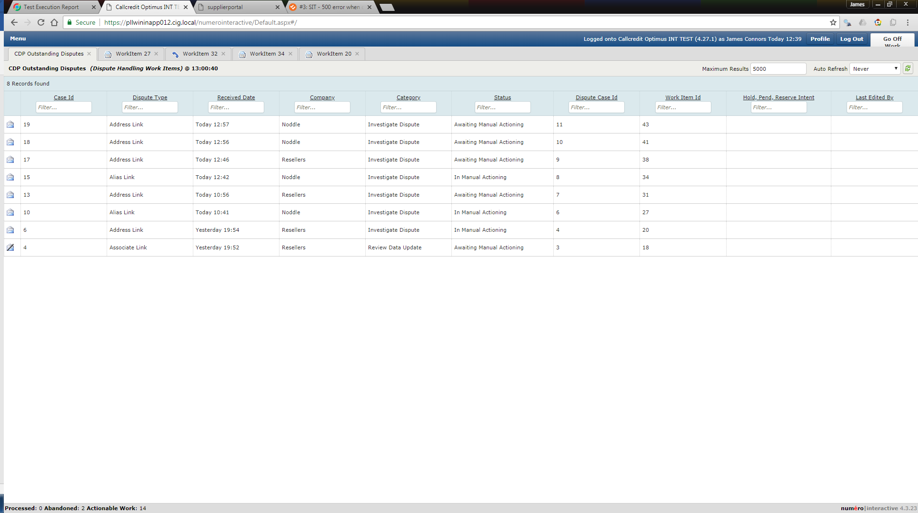

A second manual dipute is then raised against the same consumer;

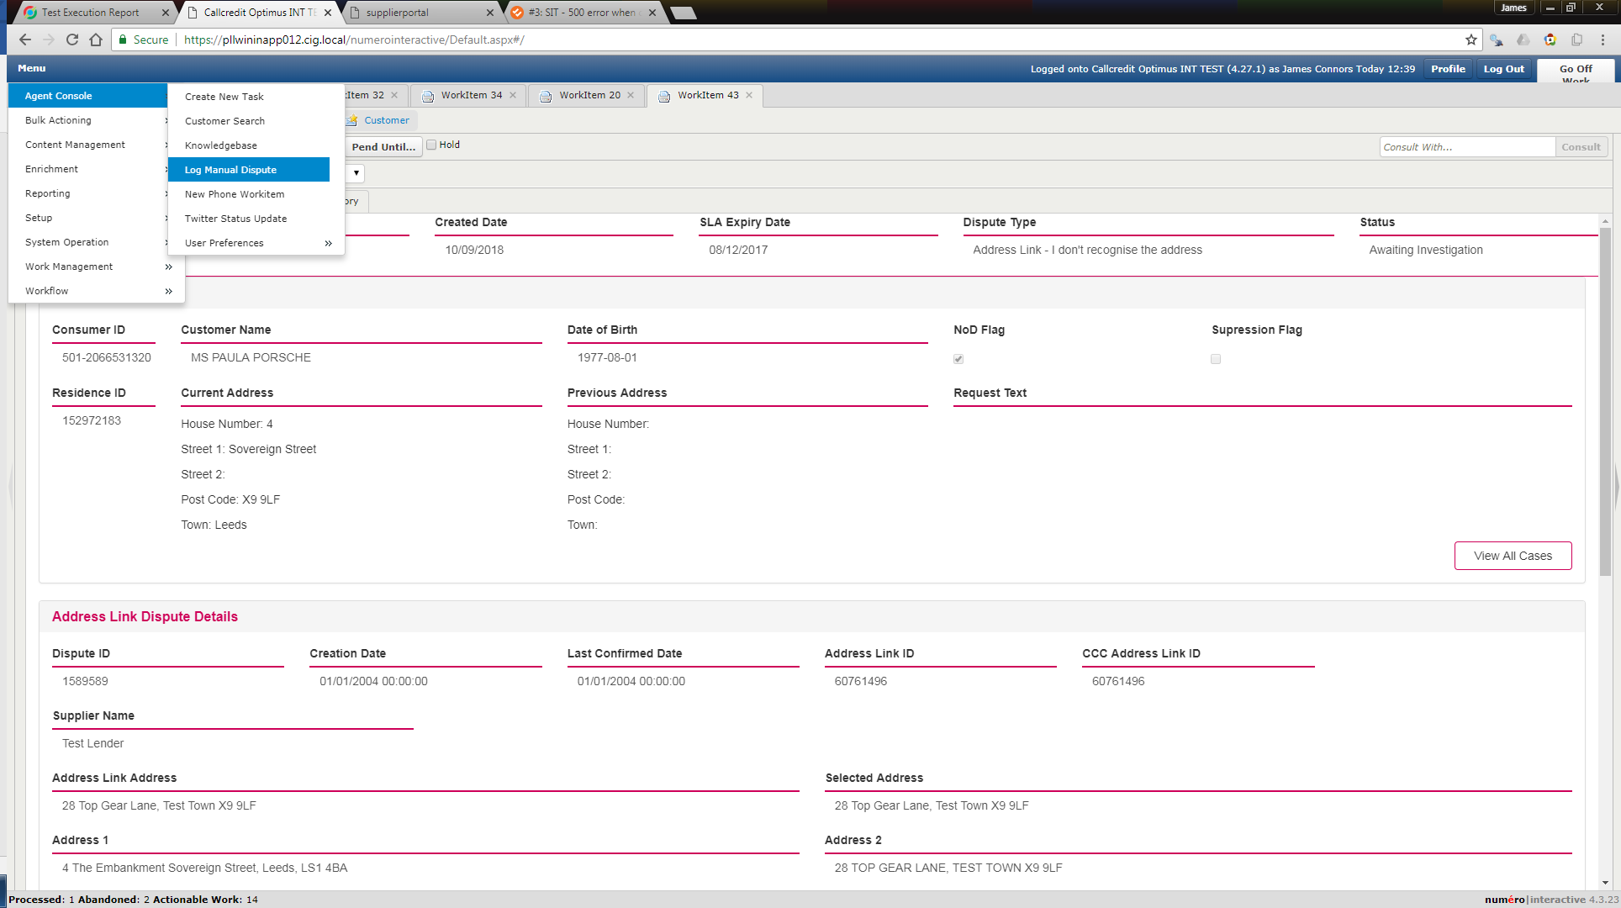

Consumer details entered

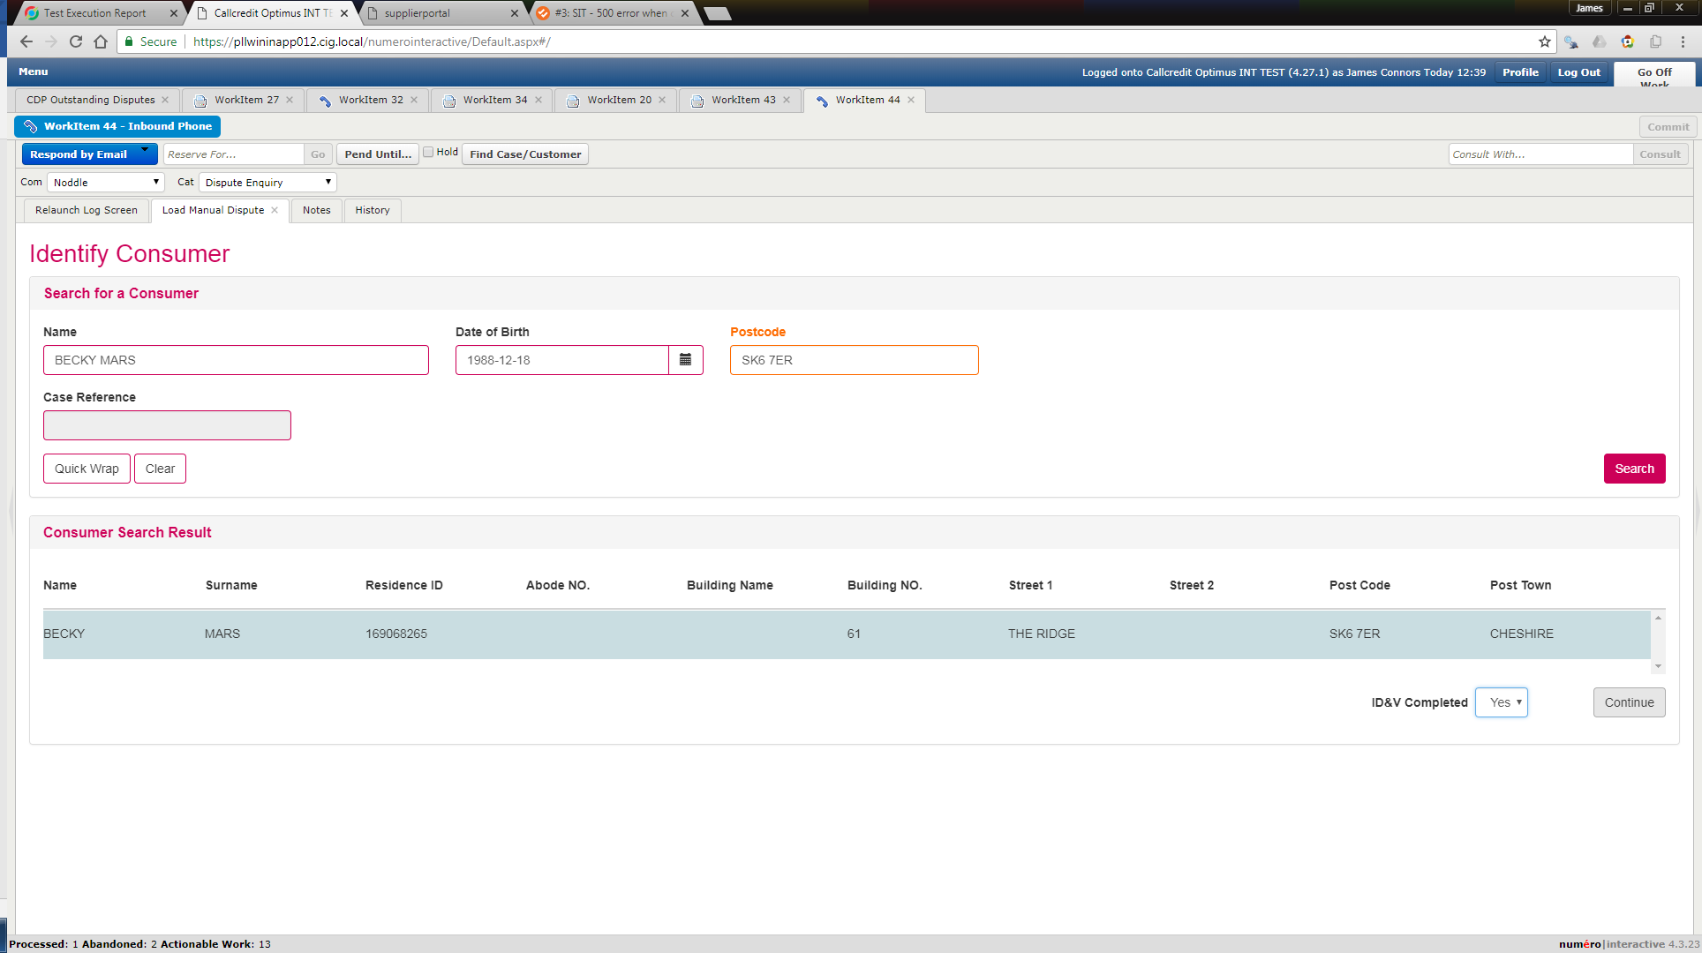

Case Linking picker dialogue includes the first created dispute that has not yet been created as 5 mins not yet elapse, note that Case Ref is blank

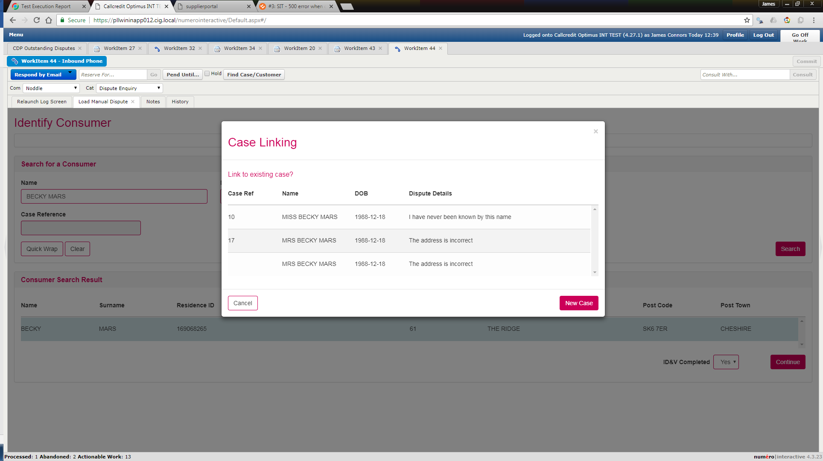

Wait 5 mins for the created Address Link dispute to be created and searchable;

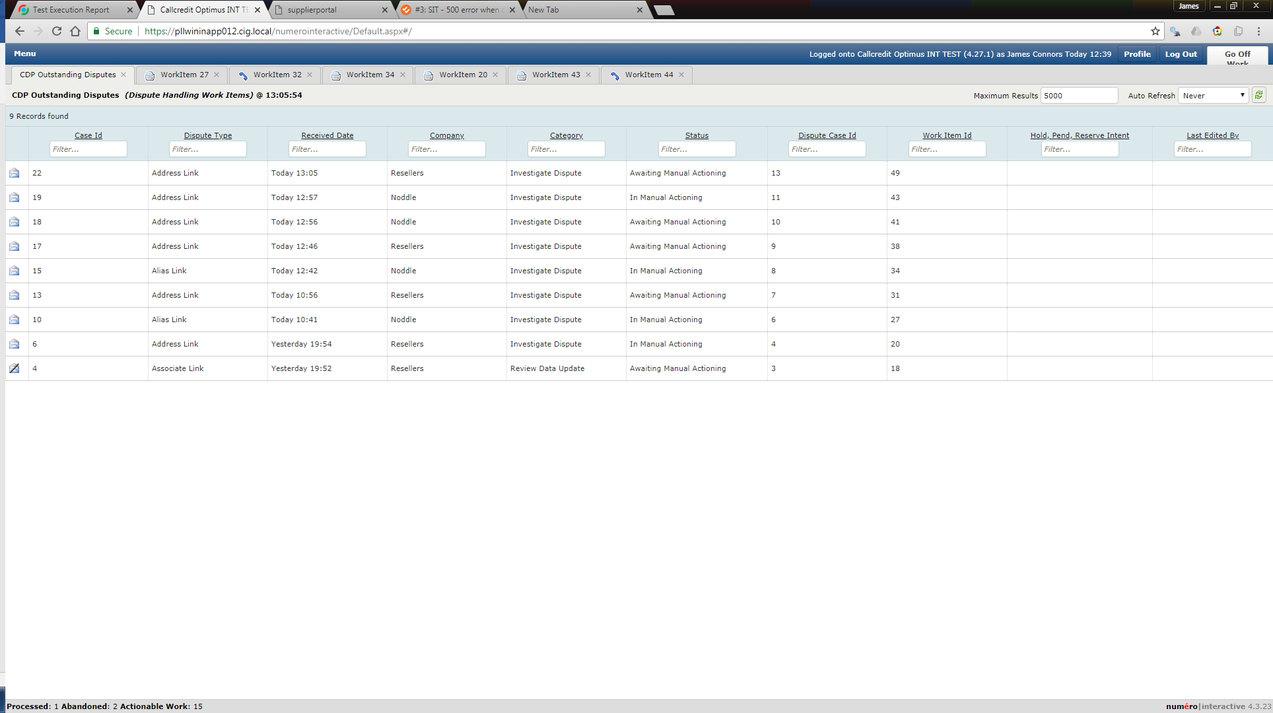

Try again;

Case Ref displayed correctly;

